|  |  |
| --- | --- |
| **International General Certificate of Secondary Education** |  |
| **CAMBRIDGE INTERNATIONAL EXAMINATIONS**  **CHEMISTRY** | **0620/1** |
| PAPER 2 Multiple Choice |  |

45 minutes

Additional materials:

Multiple Choice answer sheet

Soft clean eraser

Soft pencil

**TIME** 45 minutes

**INSTRUCTIONS TO CANDIDATES**

**Do not open this booklet until you are told to do so.**

Write your name, Centre number and candidate number on the answer sheet in the spaces provided unless this has already been done for you.

There are **forty** questions in this paper. Answer **all** questions. For each question, there are four possible answers, **A**, **B**, **C** and **D**. Choose the **one** you consider correct and record your choice in **soft pencil** on the separate answer sheet.

**Read very carefully the instructions on the answer sheet.**

**INFORMATION FOR CANDIDATES**

Each correct answer will score one mark. A mark will not be deducted for a wrong answer. Any rough working should be done in this booklet.

A copy of the Periodic Table is printed on page 16.

**This question paper consists of 16 printed pages.**

**1** Heating a liquid causes it to become a vapour.

What happens to the molecules of the liquid during this process?

|  |  |  |
| --- | --- | --- |
| the molecules | | the molecules move further apart |
| become bigger | |
| **A** | ✓ | ✓ |
| **B** | ✓ | ✗ |
| **C** | ✗ | ✓ |
| **D** | ✗ | ✗ |

**2** Some sugar is dissolved in water.

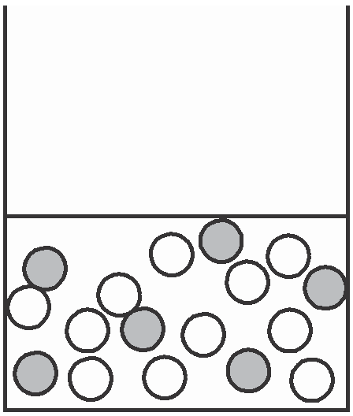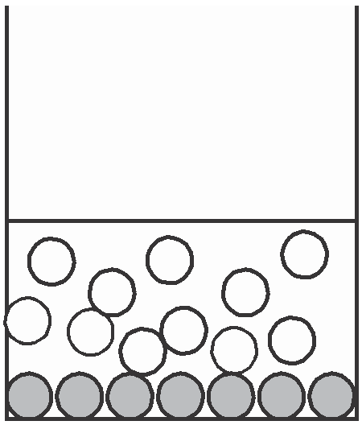

Which diagram shows how the particles are arranged in the solution?

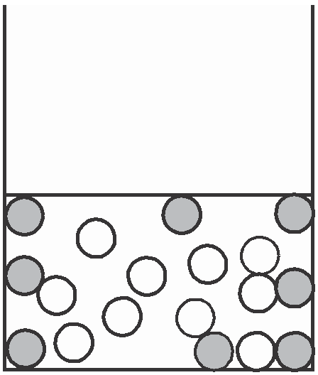

key

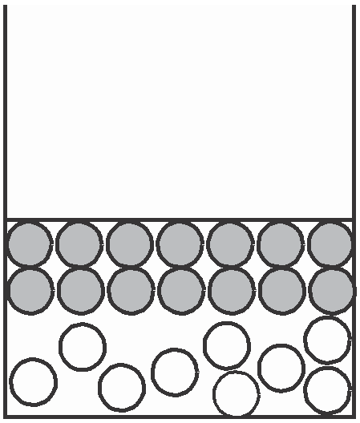

sugar particle water particle

**A B C D**

**3** Which stages occur in distillation?

**A** condensation then evaporation

**B** condensation then filtration

**C** evaporation then condensation

**D** filtration then evaporation

**4** Some paraffin is contaminated with soot (carbon). The soot is removed as shown.

paraffin + soot

wire grid

cloth

clean paraffin

Which method is used to remove the soot?

**A** cracking

**B** crystallisation

**C** diffusion

**D** filtration

**5** The diagrams show the nuclei of four different atoms.

Q R S T

key

10 p 10 p

12 p

14 p

p = proton

10 n 12 n 14 n 14 n

n = neutron

Which two atoms are isotopes of each other?

**A** Q and R **B** Q and T **C** R and S **D** S and T

**6** Which atom has twice as many neutrons as protons?

4

1H **B**

**A** 1

2

3

1H **C**

1H **D**

2He

**7** Which change takes place when an atom becomes a positive ion?

**A** An electron is added.

**B** An electron is removed.

**C** A proton is added.

**D** A proton is removed.

**8** The diagram shows an electric circuit.

bulb

**X Y**

For which two substances at **X** and **Y** does the bulb light up?

|  |  |  |
| --- | --- | --- |
| **X** | | **Y** |
| **A** | copper | graphite |
| **B** | copper | poly(ethene) |
| **C** | rubber | graphite |
| **D** | rubber | poly(ethene) |

**9** One method of producing carbon dioxide is to react calcium carbonate with dilute hydrochloric acid.

What is the balanced chemical equation for the reaction?

**A** CaCO3 + HC*l* → CaO + CO2 + HC*l*

**B** CaCO3 + 2HC*l* → CaC*l*2 + CO2 + H2O

**C** CaCO3 + 4HC*l* → CaC*l*4 + CO2 + H2 + H2O

**D** Ca(HCO3)2 + HC*l* → CaC*l* + 2CO2 + H2O

**10** A gas has the molecular formula NOC*l*.

Which diagram could show molecules of the pure gas NOC*l*?

**A B C D**

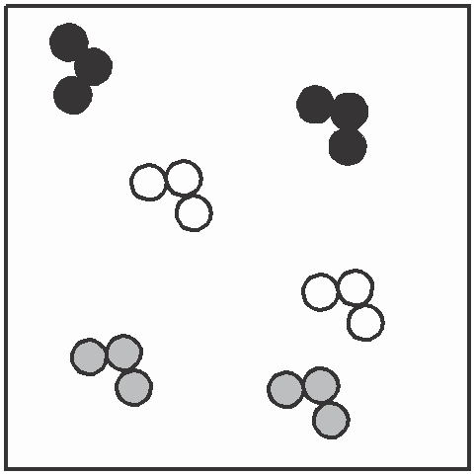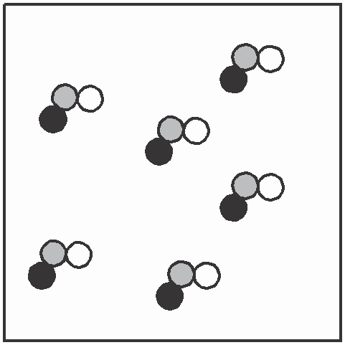

**11** Butenedioic acid has the structure shown.

key

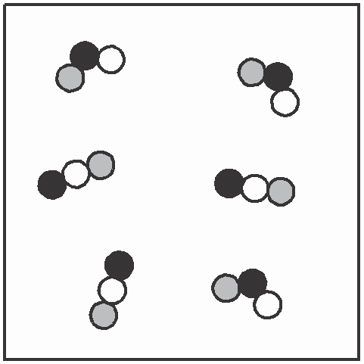

N C*l* O

O

H C H C O

H C O H C

O

What is the molecular formula of butenedioic acid?

**A** CHO **B** C4H4O4 **C** C6H4O2 **D** C6H4O6

**12** The diagram represents the electrolysis of brine (aqueous sodium chloride).

brine chlorine **X**

**Y**

+ –

positive electrode

porous wall

negative electrode

What are products **X** and **Y**?

|  |  |  |
| --- | --- | --- |
| **X** | | **Y** |
| **A** | hydrogen | aqueous sodium hydroxide hydrochloric acid  aqueous sodium hydroxide  hydrochloric acid |
| **B** | hydrogen |
| **C** | oxygen |
| **D** | oxygen |

**13** Copper wires in an electricity cable are covered in plastic.

plastic

plastic

copper wire

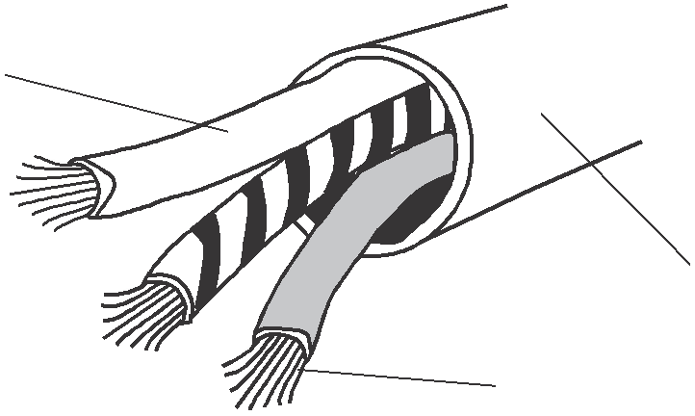

Why is plastic used?

**A** It is an insulator.

**B** It is a polymer.

**C** It is hard.

**D** It melts easily.

**14** A piece of magnesium is dropped into a test-tube containing dilute hydrochloric acid.

bubbles

magnesium

dilute hydrochloric acid

Why does the test-tube become warm?

**A** Hydrogen is produced.

**B** The magnesium neutralises the acid.

**C** The reaction is endothermic.

**D** The reaction is exothermic.

**15** An explosion in a coal mine was caused by the ignition of a mixture of methane and air.

Why did the mixture explode?

**A** The heat absorbed by burning decreased the rate of burning. **B** The heat absorbed by burning increased the rate of burning. **C** The heat liberated by burning decreased the rate of burning. **D** The heat liberated by burning increased the rate of burning.

**16** The diagram shows an experiment to compare the speed of reaction when limestone chips are added to acid.

**A B C D**

concentrated acid

concentrated acid

dilute

acid

dilute

acid

acid acid

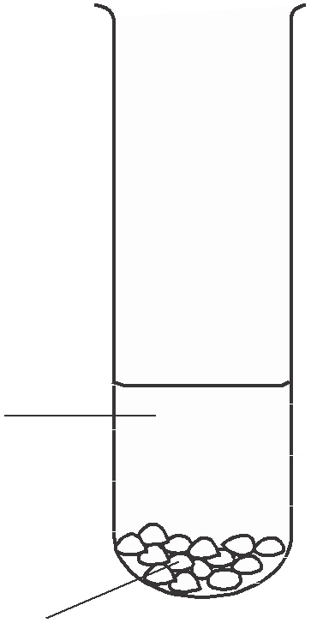

limestone limestone

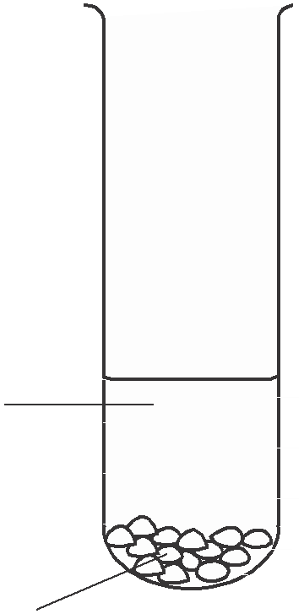

In which test-tube is the reaction most rapid?

**17** Which properties does a transition element have?

|  |  |  |
| --- | --- | --- |
| density | | melting point |
| **A** | high | high |
| **B** | high | low |
| **C** | low | high |
| **D** | low | low |

**18** Which metals can be obtained by heating their oxides with carbon?

|  |  |  |  |
| --- | --- | --- | --- |
| copper | | iron | magnesium |
| **A** | ✗ | ✓ | ✓ |
| **B** | ✓ | ✓ | ✗ |
| **C** | ✗ | ✗ | ✓ |
| **D** | ✓ | ✗ | ✗ |

**19** Aqueous lead(II) nitrate is added to a solution containing iodide ions. Lead(II) iodide is formed.

Which type of reaction takes place?

**A** neutralisation

**B** oxidation

**C** precipitation

**D** reduction

**20** Which element reacts with dilute sulphuric acid to produce hydrogen?

**A** carbon **B** chlorine **C** copper **D** zinc

**21** For which pH change is there the largest increase in acidity?

|  |  |  |
| --- | --- | --- |
|  | initial pH | final pH |
| **A** | 1 | 3 |
| **B** | 2 | 6 |
| **C** | 3 | 1 |
| **D** | 6 | 2 |

**22** Which statement about the electrical conductivity of non-metals and the charge on their ions is correct?

|  |  |  |
| --- | --- | --- |
| electrical | | charge on ions |
| conductivity | |
| **A** | good | positive |
| **B** | good | negative |
| **C** | poor | positive |
| **D** | poor | negative |

**23** The corrosion of iron and its extraction from hematite are important processes.

Which terms describe the corrosion of iron and its extraction from hematite?

|  |  |  |
| --- | --- | --- |
| corrosion | | extraction |
| **A** | oxidation | oxidation |
| **B** | oxidation | reduction |
| **C** | reduction | oxidation |
| **D** | reduction | reduction |

**24** A few drops of aqueous bromine are added to separate aqueous solutions of potassium chloride, potassium bromide and potassium iodide.

Which solutions do **not** remove the colour of the bromine?

**A** KBr and KC*l* only

**B** KBr and KI only **C** KC*l* and KI only **D** KBr, KC*l* and KI

**25** Which metal produces a solution of a metal hydroxide when added to water?

**A** calcium **B** copper **C** iron

**D** zinc

**26** A highly reactive metal is likely to

**A** form negative ions,

**B** occur naturally as an element,

**C** occur only as an oxide,

**D** oxidise rapidly in air.

**27** The diagram shows the manufacture of steel.

waste gases

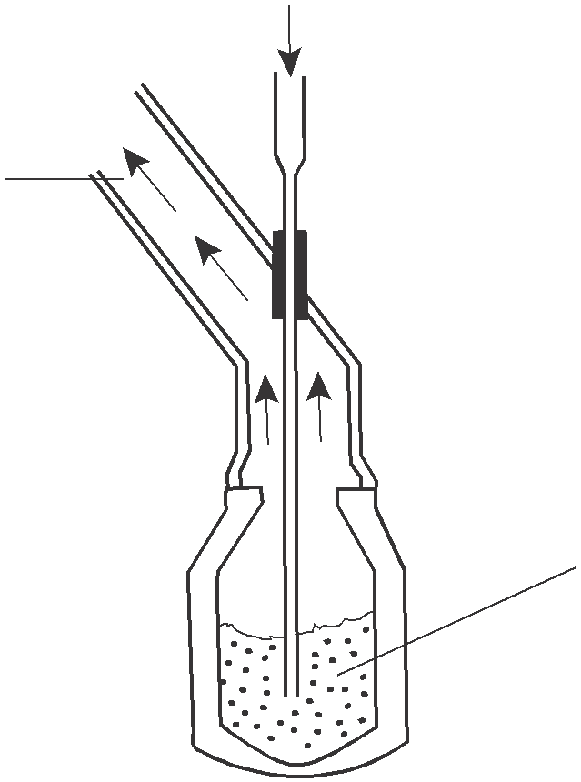

What could gas **X** be?

**A** carbon dioxide

**B** chlorine

**C** hydrogen

**D** oxygen

**28** A student writes the following statements.

gas **X**

molten iron

1 Aluminium is used in the manufacture of aircraft bodies.

2 Aluminium is used to make stainless steel.

3 Mild steel is used in the manufacture of car bodies. Which statements are correct?

**A** 1 and 2 only **B** 1 and 3 only **C** 2 and 3 only **D** 1, 2 and 3

**29** Which substance is used in the purification of water?

**A** calcium sulphate

**B** carbon dioxide

**C** chlorine

**D** sodium chloride

**30** Which pollutant, found in car exhaust fumes, does **not** come from the fuel?

**A** carbon monoxide

**B** hydrocarbons

**C** lead compounds

**D** nitrogen oxides

**31** Which place on the map is most likely to be producing large quantities of sulphur dioxide?

sea

coal-fired power station **B**

farm

**A**

water

**C** purification plant

petrol station in village

**D**

**32** Why does a bicycle chain that is coated with oil **not** rust?

**A** Oil dissolves any rust that forms.

**B** Oil reacts with rust causing oxidation.

**C** Oil reacts with oxygen so no rust forms.

**D** Oil stops oxygen and water getting to the chain.

**33** Which two other compounds should be added to ammonium sulphate to make a complete NPK

fertiliser?

**A** KNO3, Na2HPO4

**B** K2SO4, KNO3

**C** NaC*l*, Ca3(PO4)2

**D** NH4C*l*, Na2HPO4

**34** Two uses of oxygen are

1 burning acetylene in welding,

2 helping the breathing of hospital patients. Which of these uses form carbon dioxide?

|  |  |  |
| --- | --- | --- |
|  | use 1 | use 2 |
| **A** | ✓ | ✓ |
| **B** | ✓ | ✗ |
| **C** | ✗ | ✓ |
| **D** | ✗ | ✗ |

**35** Lime is used to treat an industrial waste.

untreated waste

treated waste

lime

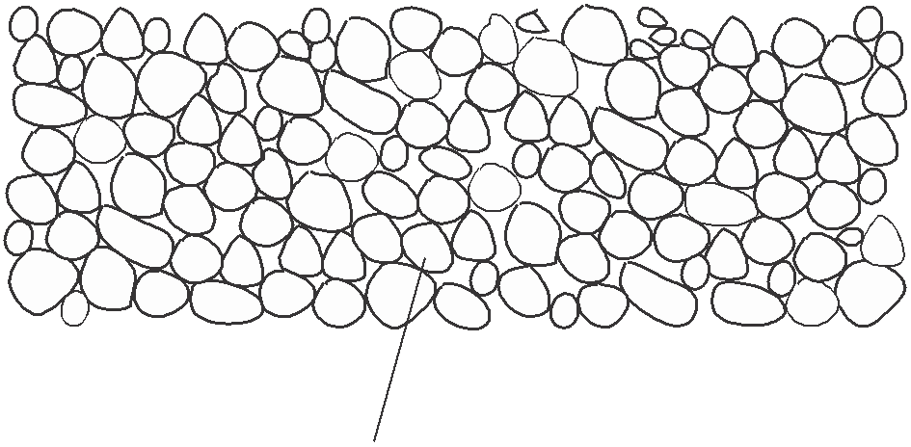

Which pH change occurs in the treatment?

|  |  |  |  |
| --- | --- | --- | --- |
|  | untreated waste | → | treated waste |
| **A** | acidic | → | neutral |
| **B** | alkaline | → | acidic |
| **C** | alkaline | → | neutral |
| **D** | neutral | → | acidic |

**36** A compound **Q** has the structure shown.

H H H H C C C

H H H

H H H C C C

H H H

H

C O H H

What is the name of **Q**?

**A** heptane

**B** heptanoic acid

**C** heptanol

**D** heptene

**37** A student sets up the apparatus shown to separate petroleum into its different liquid parts.

themometer

|  |  |  |
| --- | --- | --- |
|  |  | |
|  | |
|  |  |  |
|  |  | |

petroleum on rock wool

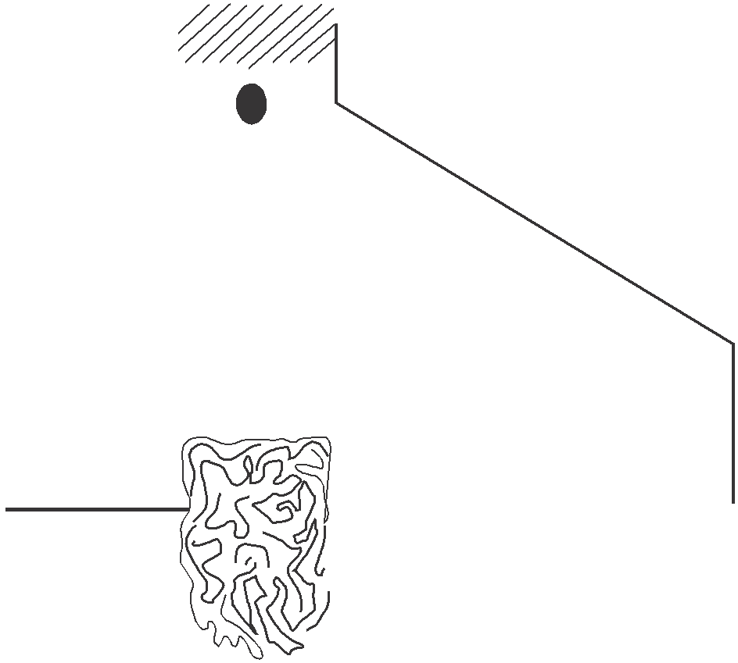

cold water

heat

Why does this method of separation work?

The liquids in petroleum have different

**A** boiling points,

**B** densities,

**C** functional groups,

**D** melting points.

**38** Which row in the table correctly shows properties of decane?

|  |  |  |
| --- | --- | --- |
| burns | | is unsaturated |
| **A** | ✓ | ✓ |
| **B** | ✓ | ✗ |
| **C** | ✗ | ✓ |
| **D** | ✗ | ✗ |

**39** The equation shows the cracking of a hydrocarbon.

H H H H H H H H

H C C

C C H

C=C–C–H

+ H– C –H

H H H

H H H H

**X Y Z**

Which compounds are unsaturated?

**A X** only **B Y** only **C X** and **Z D Y** and **Z**

**40** A student states that

*ethanol reacts with water to form beer and wine; ethanol and water are used as solvents in industry.* Which of the underlined words are correct?

|  |  |  |
| --- | --- | --- |
| reacts | | solvents |
| **A** | ✓ | ✓ |
| **B** | ✓ | ✗ |
| **C** | ✗ | ✓ |
| **D** | ✗ | ✗ |

0620/1/O/N/02

**DATA SHEET**

**The Periodic Table of the Elements**

*58-71 Lanthanoid series

†90-103 Actinoid series

a

0620/1/O/N/02

**16**

Key **X**

b

a = relative atomic mass

**X** = atomic symbol

|  |  |  |  |  |  |  |  |  |  |  |  |  |  |  |  |  |  |
| --- | --- | --- | --- | --- | --- | --- | --- | --- | --- | --- | --- | --- | --- | --- | --- | --- | --- |
| **Group** | | | | | | | | | | | | | | | | | |
| I | II |  |  |  |  |  |  |  |  |  | III | | IV | V | VI VII | | 0 |
|  |  |  |  |  |  |  | 1 |  |  |  |  |  |  |  |  |  | 4 |
|  |  |  |  |  |  |  | **H** |  |  |  |  |  |  |  |  |  | **He** |
|  |  |  |  |  |  |  | Hydrogen |  |  |  |  |  |  |  |  |  | Helium |
|  |  |  |  |  |  |  | 1 |  |  |  |  |  |  |  |  |  | 2 |
| 7 | 9 |  |  |  |  |  |  |  |  |  |  | 11 | 12 | 14 | 16 | 19 | 20 |
| **Li** | **Be** |  |  |  |  |  |  |  |  |  |  | **B** | **C** | **N** | **O** | **F** | **Ne** |
| Lithium | Beryllium |  |  |  |  |  |  |  |  |  |  | Boron | Carbon | Nitrogen | Oxygen | Fluorine | Neon |
| 3 | 4 |  |  |  |  |  |  |  |  |  |  | 5 | 6 | 7 | 8 | 9 | 10 |
| 23 24 | |  |  |  |  |  |  |  |  |  |  | 27 | 28 31 | | 32 | 35.5 | 40 |
| **Na Mg** | |  |  |  |  |  |  |  |  |  |  | **A***l* | **Si P** | | **S** | **C***l* | **Ar** |
| Sodium Magnesium | |  |  |  |  |  |  |  |  |  |  | Aluminium | Silicon Phosphorus | | Sulphur | Chlorine | Argon |
| 11 12 | |  |  |  |  |  |  |  |  |  |  | 13 | 14 15 | | 16 | 17 | 18 |
| 39 | 40 | 45 | 48 | 51 | 52 55 | | 56 | 59 | 59 | 64 | 65 | 70 73 | | 75 | 79 | 80 | 84 |
| **K** | **Ca** | **Sc** | **Ti** | **V** | **Cr Mn** | | **Fe** | **Co** | **Ni** | **Cu** | **Zn** | **Ga Ge** | | **As** | **Se** | **Br** | **Kr** |
| Potassium | Calcium | Scandium | Titanium | Vanadium | Chromium Manganese | | Iron | Cobalt | Nickel | Copper | Zinc | Gallium Germanium | | Arsenic | Selenium | Bromine | Krypton |
| 19 | 20 | 21 | 22 | 23 | 24 25 | | 26 | 27 | 28 | 29 | 30 | 31 32 | | 33 | 34 | 35 | 36 |
| 85 | 88 | 89 | 91 | 93 96 | |  | 101 | 103 | 106 | 108 | 112 | 115 | 119 | 122 | 128 | 127 | 131 |
| **Rb** | **Sr** | **Y** | **Zr** | **Nb Mo** | | **Tc** | **Ru** | **Rh** | **Pd** | **Ag** | **Cd** | **In** | **Sn** | **Sb** | **Te** | **I** | **Xe** |
| Rubidium | Strontium | Yttrium | Zirconium | Niobium Molybdenum | | Technetium | Ruthenium | Rhodium | Palladium | Silver | Cadmium | Indium | Tin | Antimony | Tellurium | Iodine | Xenon |
| 37 | 38 | 39 | 40 | 41 42 | | 43 | 44 | 45 | 46 | 47 | 48 | 49 | 50 | 51 | 52 | 53 | 54 |
| 133 | 137 | 139 | 178 | 181 | 184 | 186 | 190 | 192 | 195 | 197 | 201 | 204 | 207 | 209 |  |  |  |
| **Cs** | **Ba** | **La** | **Hf** | **Ta** | **W** | **Re** | **Os** | **Ir** | **Pt** | **Au** | **Hg** | **T***l* | **Pb** | **Bi** | **Po** | **At** | **Rn** |
| Caesium | Barium | Lanthanum | Hafnium | Tantalum | Tungsten | Rhenium | Osmium | Iridium | Platinum | Gold | Mercury | Thallium | Lead | Bismuth | Polonium | Astatine | Radon |
| 55 | 56 | 57 * | 72 | 73 | 74 | 75 | 76 | 77 | 78 | 79 | 80 | 81 | 82 | 83 | 84 | 85 | 86 |
|  | 226 | 227 |  |  |  |  |  |  |  |  |  |  |  |  |  |  |  |
| **Fr** | **Ra** | **Ac** |  |  |  |  |  |  |  |  |  |  |  |  |  |  |  |
| Francium | Radium | Actinium |  |  |  |  |  |  |  |  |  |  |  |  |  |  |  |
| 87 | 88 | 89 † |  |  |  |  |  |  |  |  |  |  |  |  |  |  |  |
|  | | | | 140 141 | | 144 |  | 150 | 152 157 | | 159 162 | | 165 | 167 | 169 | 173 | 175 |
| **Ce Pr** | | **Nd** | **Pm** | **Sm** | **Eu Gd** | | **Tb Dy** | | **Ho** | **Er** | **Tm** | **Yb** | **Lu** |
| Cerium Praseodymium | | Neodymium | Promethium | Samarium | Europium Gadolinium | | Terbium Dysprosium | | Holmium | Erbium | Thulium | Ytterbium | Lutetium |
| 58 59 | | 60 | 61 | 62 | 63 64 | | 65 66 | | 67 | 68 | 69 | 70 | 71 |
| 232 | | 238 | |  | |  |  | |  |  |  |  | |
| **Th Pa** | | **U Np** | | **Pu Am** | | **Cm** | **Bk Cf** | | **Es** | **Fm** | **Md No Lr** | | |
| Thorium Protactinium | | Uranium Neptunium | | Plutonium Americium | | Curium | Berkelium Californium | | Einsteinium | Fermium | Mendelevium Nobelium Lawrencium | | |
| 90 91 | | 92 93 | | 94 95 | | 96 | 97 98 | | 99 | 100 | 101 102 103 | | |

b = proton (atomic) number

The volume of one mole of any gas is 24 dm3 at room temperature and pressure (r.t.p.).